Suggest Something

Final Project Report

DPS924 SAA – Final Project Report

Zukhruf Khan

Friday, December 15th, 2017

**Business Statement**

I have built an Android app that allows the user to browse through a wide database of movies, tv shows, and actors, as well as view the most popular movies and tv shows, so they can get ideas on what to watch next. I used a web service known as the TMDB API (TMDB = The Movie Database) to retrieve my data.

There are various apps already out there to suggest media and display all of their details. The most prominent (and popular) is the IMDb app (<https://play.google.com/store/apps/details?id=com.imdb.mobile)>. The IMDb app is based on the renowned IMDb website, which is one of the world’s most used, and most extensive database of movies and tv shows of all types. In fact, it is sort of the reason why I wanted to make a movie suggestion app, as IMDb is the reason why I have seen many of the highest rated movies (from their Top 250 list), and I have made something that has some of the same functionality to allow users to get good movie recommendations.

Other lesser-known apps include Movie Roulette (<https://play.google.com/store/apps/details?id=appsoluts.filmroullete)> and itcher Recommendations (<https://play.google.com/store/apps/details?id=com.marcandi.itcher)>.

My app is different from other similar apps on the market because of it’s quality – since it was my first time creating an Android app on my own, it is not as complex as other apps released on the App Store. Also, it is very simple to use, just requiring simple search queries and no other long steps to get your desired results.

The end-user needs regarding this app include receiving precise (reliable) media information regarding movies and tv shows. The business values are to provide the end-users with those results, all through an easy-to-use, simple interface.

**Use Cases**

A typical user using my app could go about it somewhat like this: they want to search for a movie that they think starts with “The”. They’ve tried on Google but it doesn’t return the movie they’re looking for. In this case, they can use my app, as it will return only movies if they use the Search By Movies function. Alternatively, they can search for a tv show or actor, or even view the most popular movies/tv shows rated by TMDB users. The use cases are:

*User enters a movie title inside the search box:*

The user enters a movie title inside the search box, and clicks the Search button next to it. They will then be shown a list of results, each including the movie title, photo (if provided), and rating.

*User selects a movie to view more details about it:*

The user selects a movie (likely from the search results page). They will then be shown a page including the title, image, release year, popularity and shortened plot of the movie.

*User enters a tv show title inside the search box:*

The user enters a tv show title inside the search box, and clicks the Search button next to it. They will then be shown a list of results, each including the tv show title, photo (if provided), and rating.

*User selects a tv show to view more details about it:*

The user selects a tv show (likely from the search results page). They will then be shown a page including the title, image, first air date, popularity, and shortened plot of the tv show.

*User enters an actor’s name inside the search box:*

The user enters the name of an actor inside the search box, and clicks the Search button next to it. They will then be shown a list of results, each including the actor’s name and photo (if provided).

*User selects an actor to view more details about them:*

The user selects an actor (likely from the search results page). They will then be shown a page including the name, image, birthday, and biography of the actor.

*User selects the option to view a list of the highest rated media:*

The user selects the button or icon (possibly located on the front page) to view the highest rated movies and tv shows. They will then be shown a list of results, each result including the title, photo (if provided), and popularity. They can select the item and view more details about it as well (same as movie/tv show details).

Unfortunately, I was unable to implement the following use cases from my project proposal:

* User registration/login
* User creates watchlist
* User watches trailers

At the time of writing my project proposal document, I had not yet looked into how the API actually worked. Upon actually beginning the coding, I realized I did not have enough time to implement a user login system (which would involve connecting to the API to create a user account, and then being allowed to rate items). I did not know how to implement a watchlist either, as that would be possible with a user account, but not without one. I was also unable to implement the trailers being included in the details views, but the API did not store the link to the trailers inside the Movie and TVShow items (just a Boolean value which was video = false). Thus, I was only able to implement my originally required use cases.

**Screenshots**

Home page (MainActivity): Search Movies Query Page:

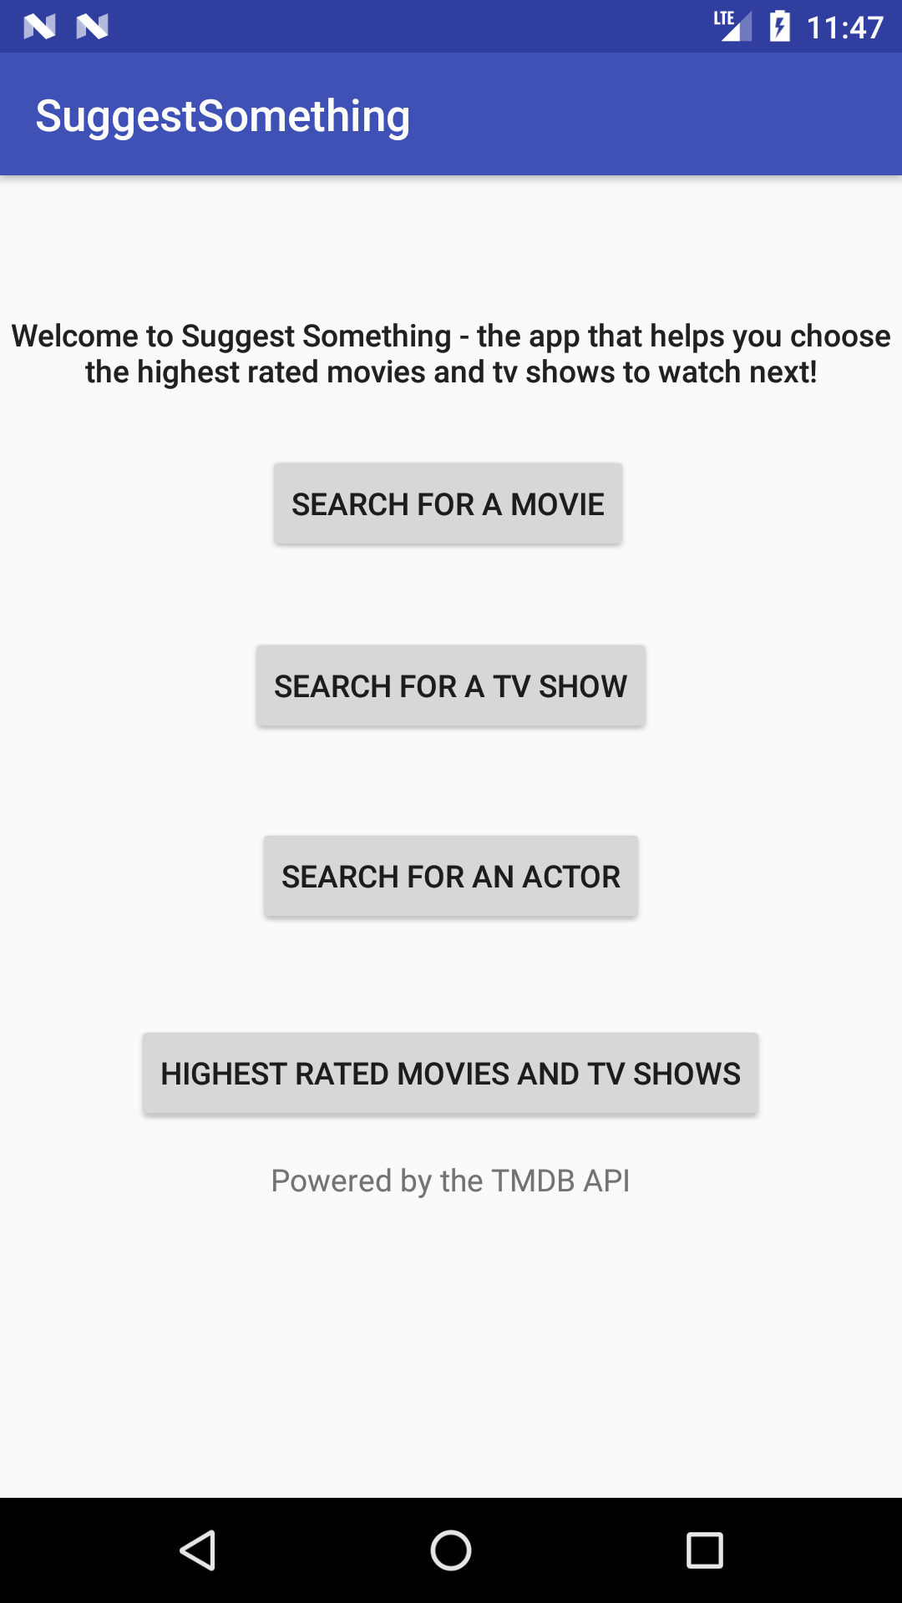 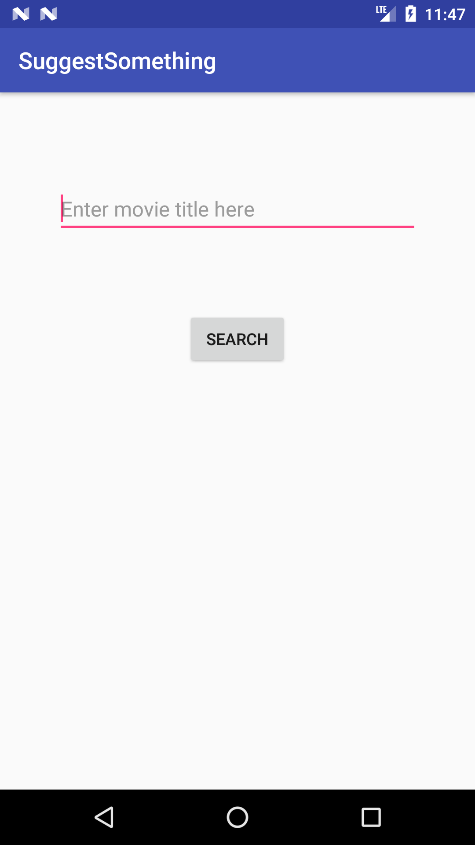

Search TV Shows Query Page: Search Actors Query Page:

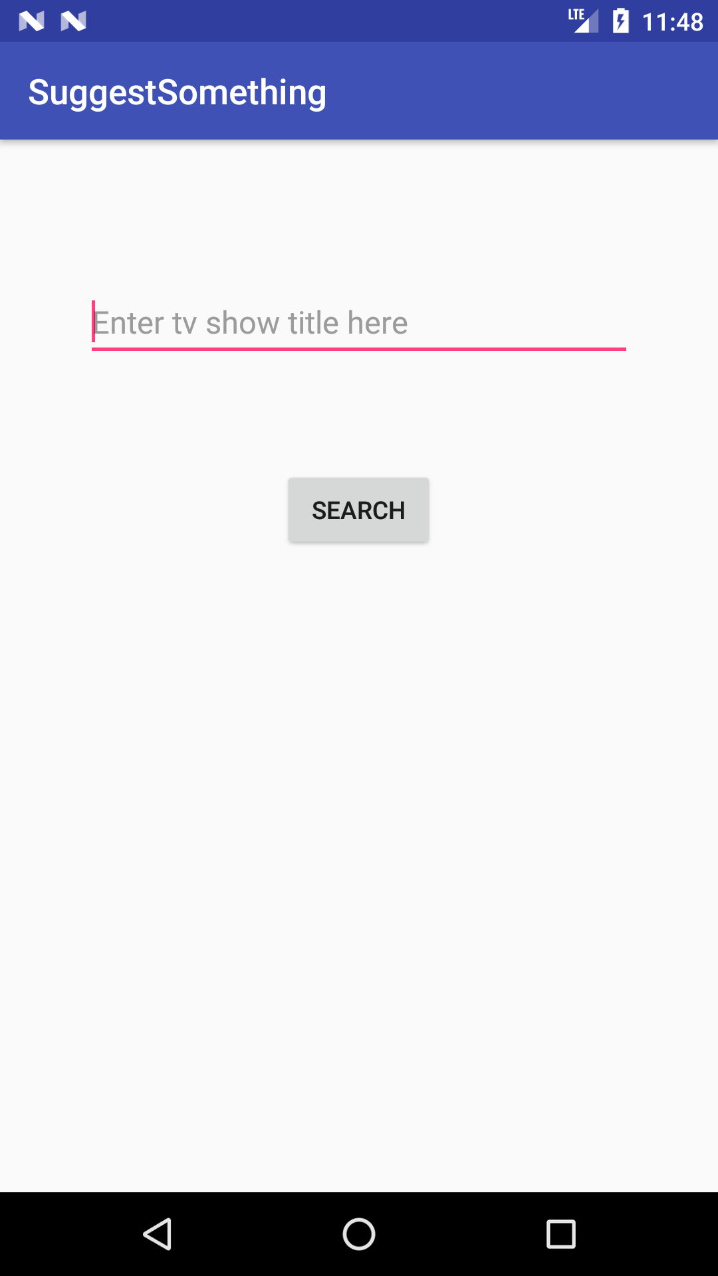 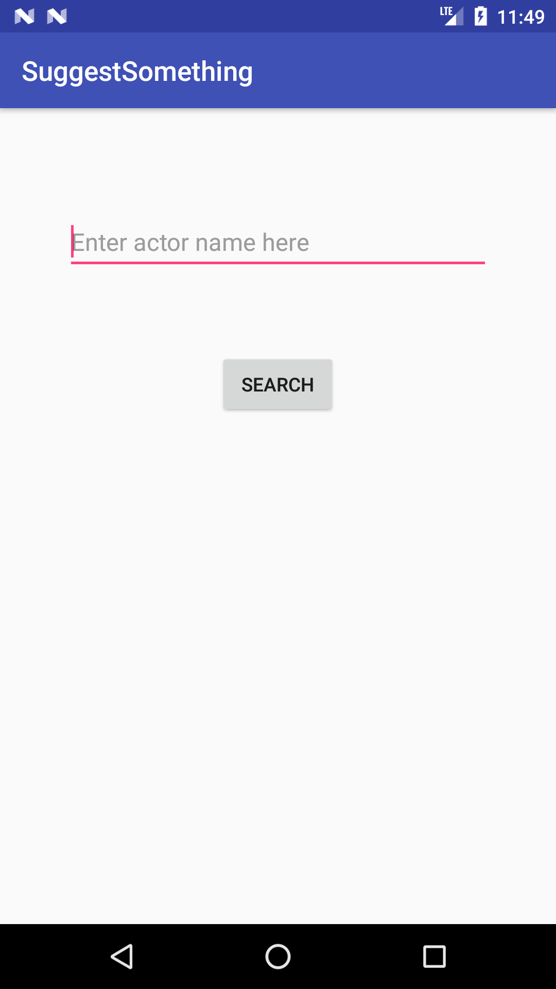

View Highest Rated Query Page Search for a Movie

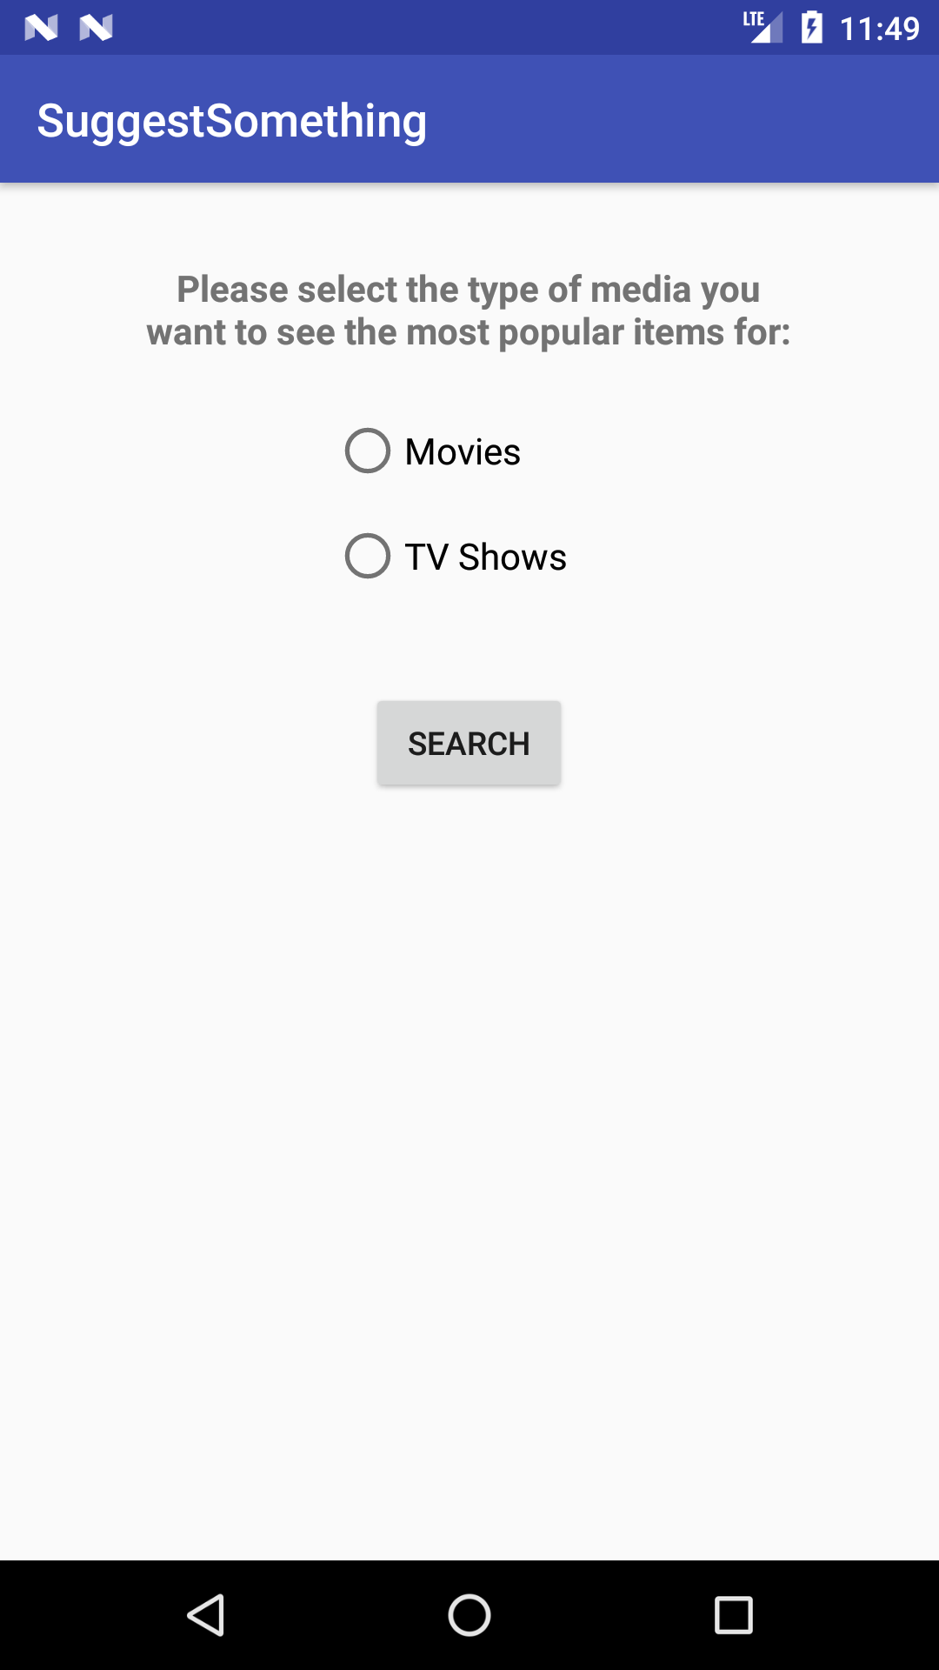 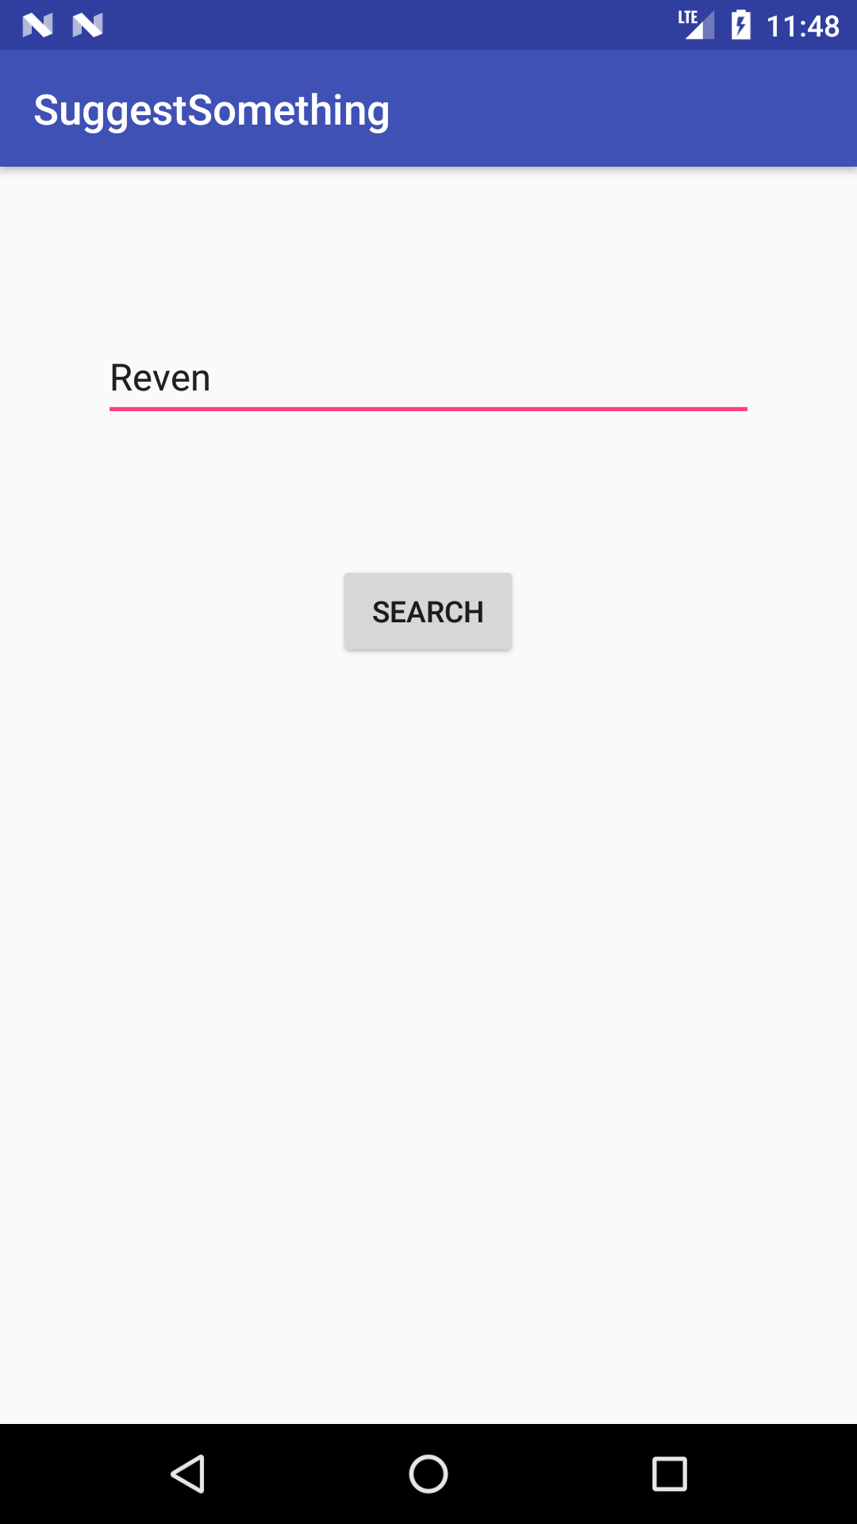

Search for a Movie Results Search for a Movie Results Details

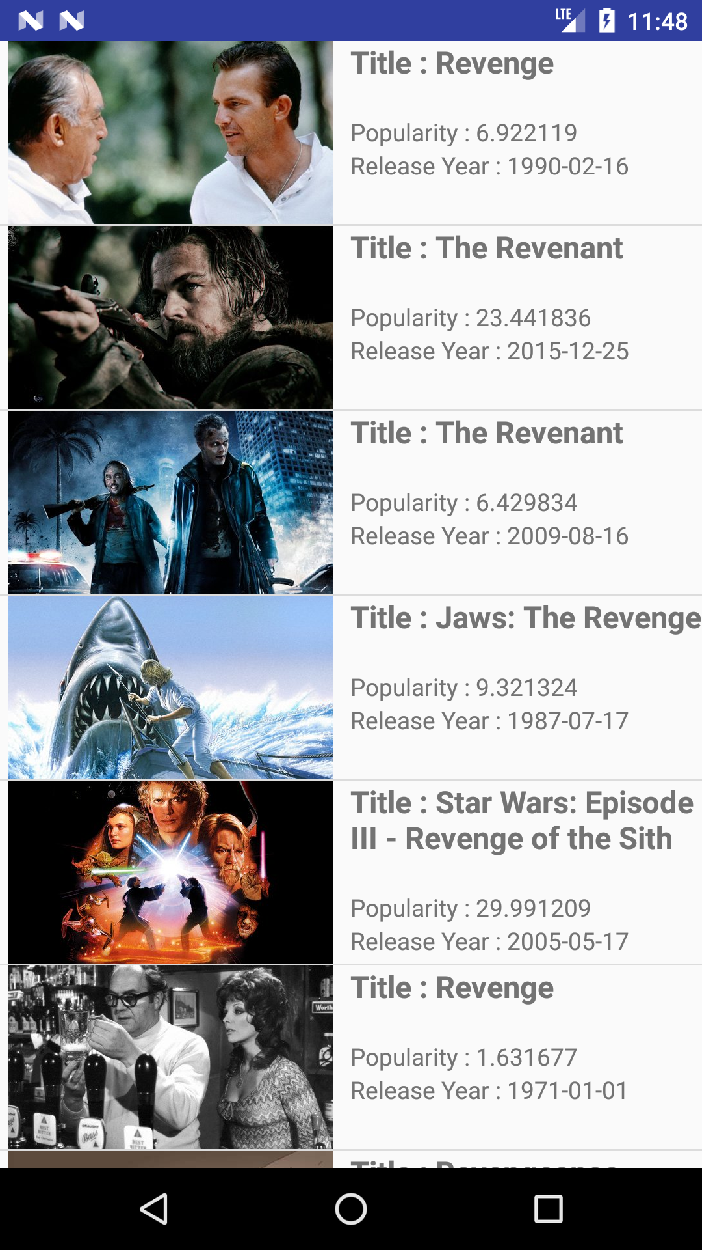 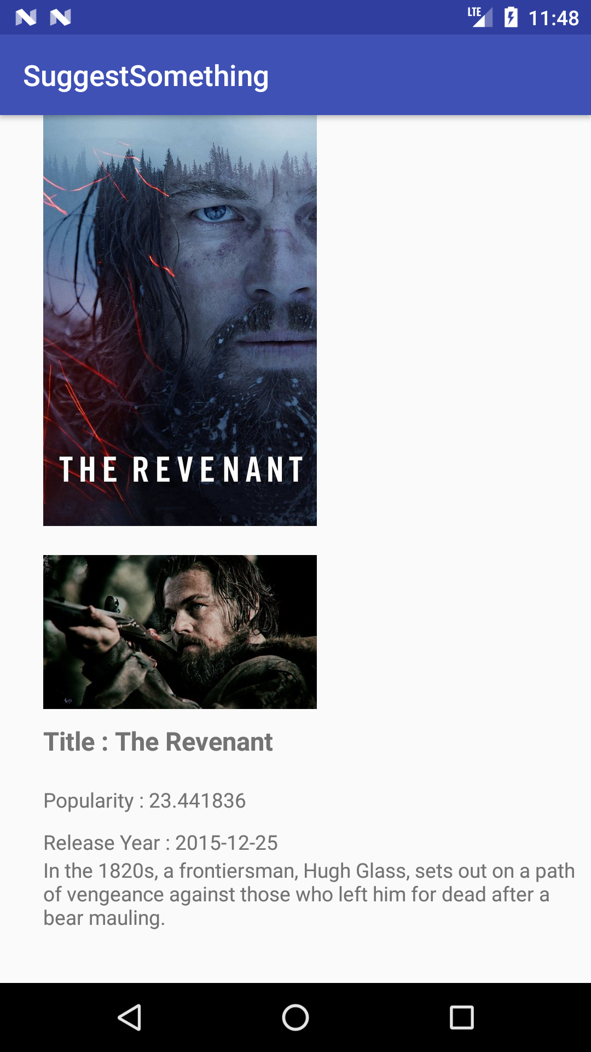

Search for a TV Show Search for a TV Show Results

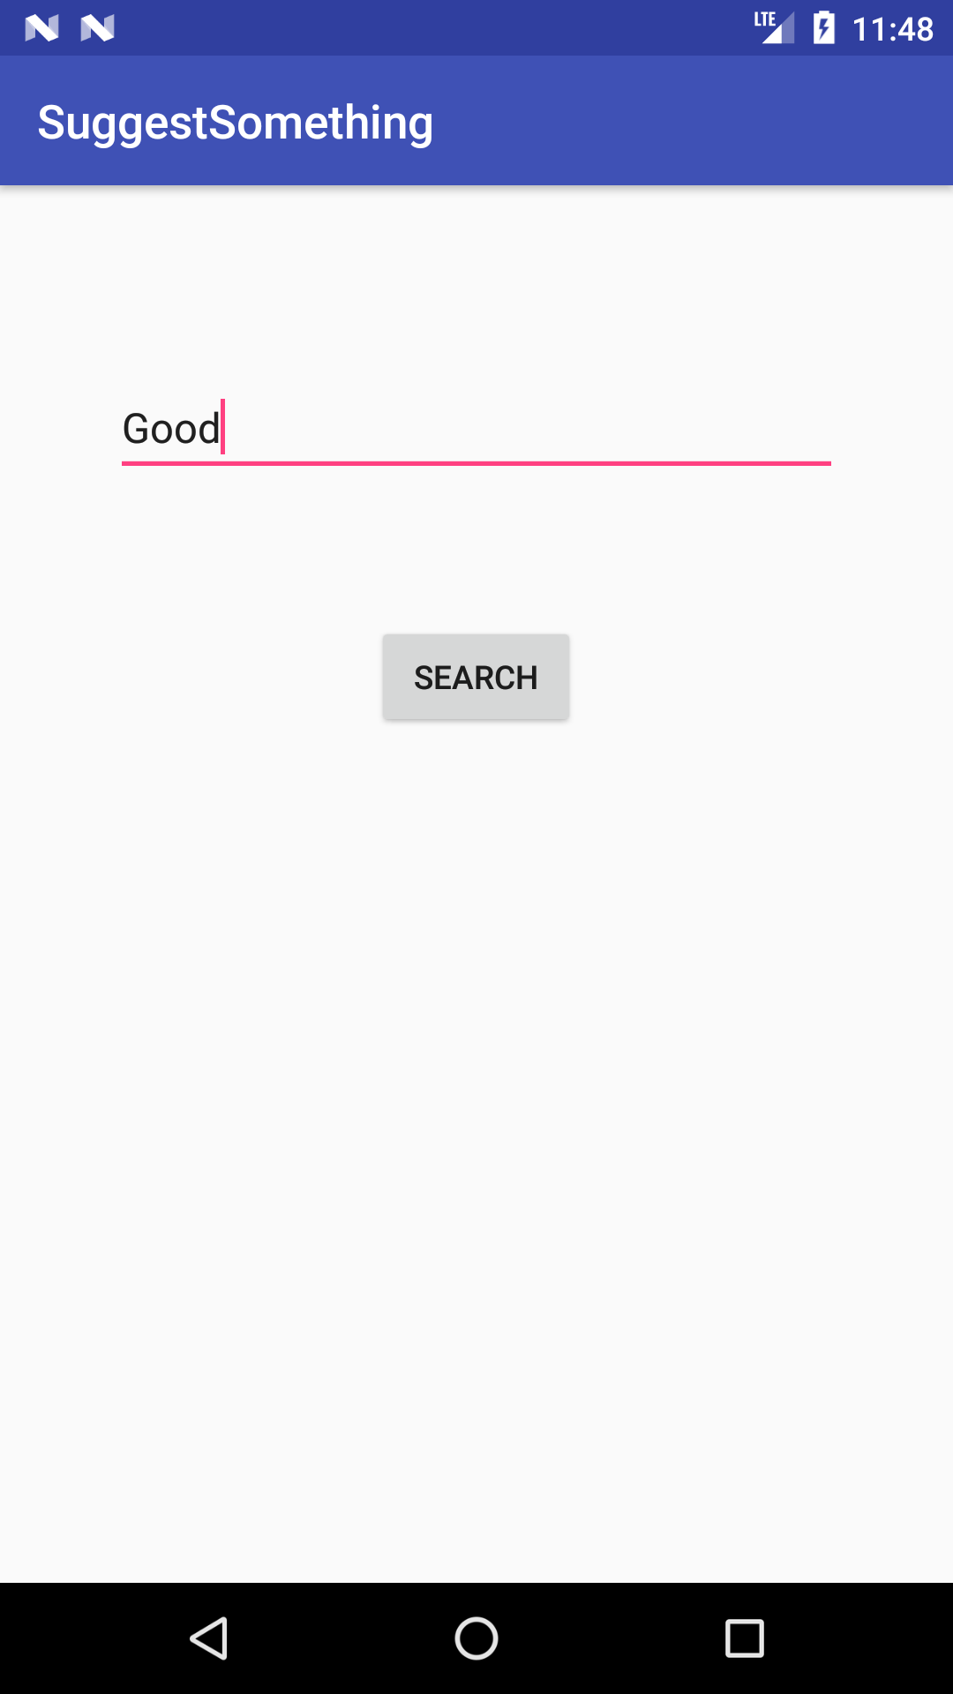 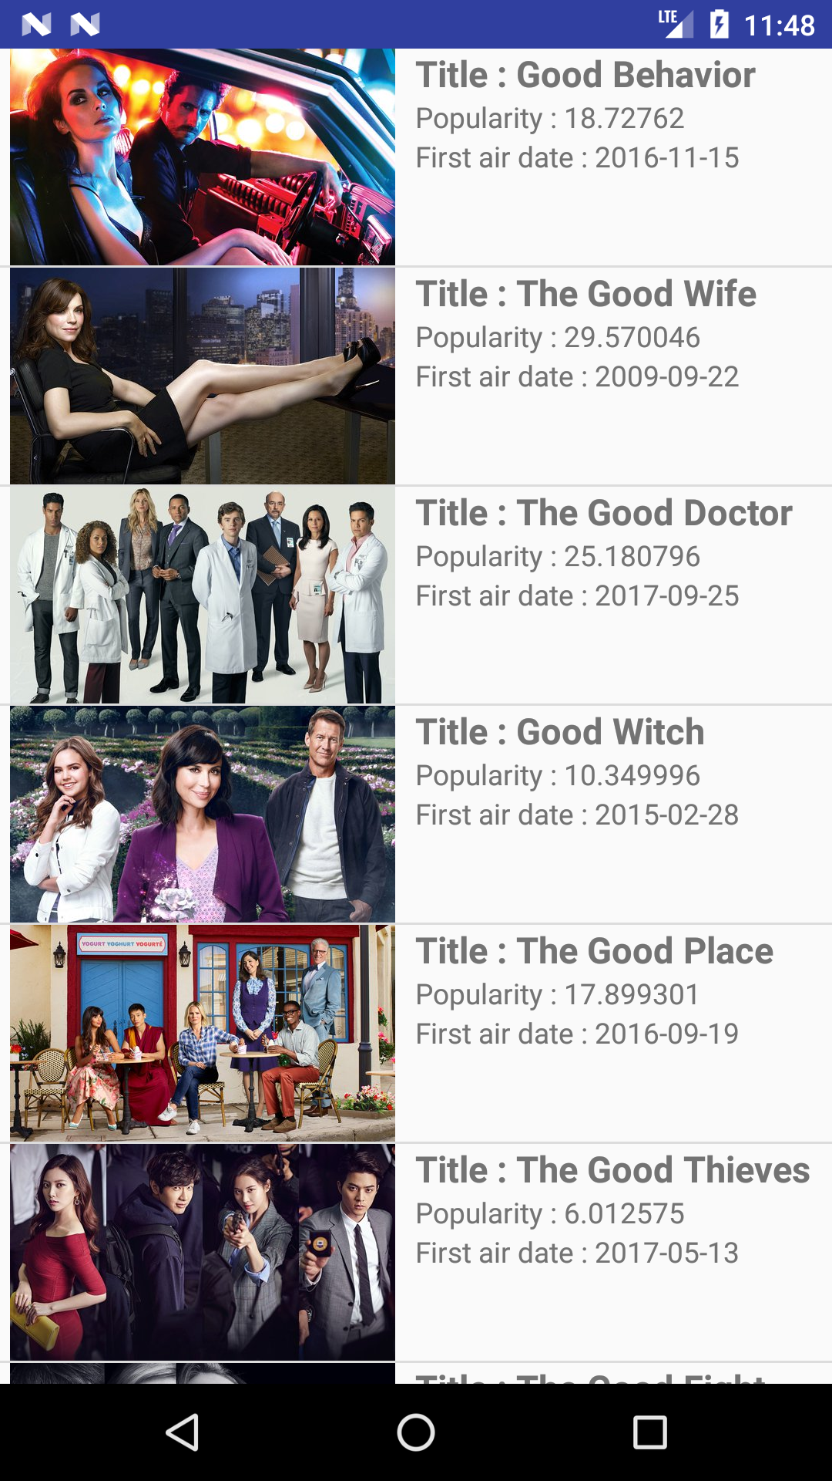

Search for a TV Show Results Details Search for an Actor

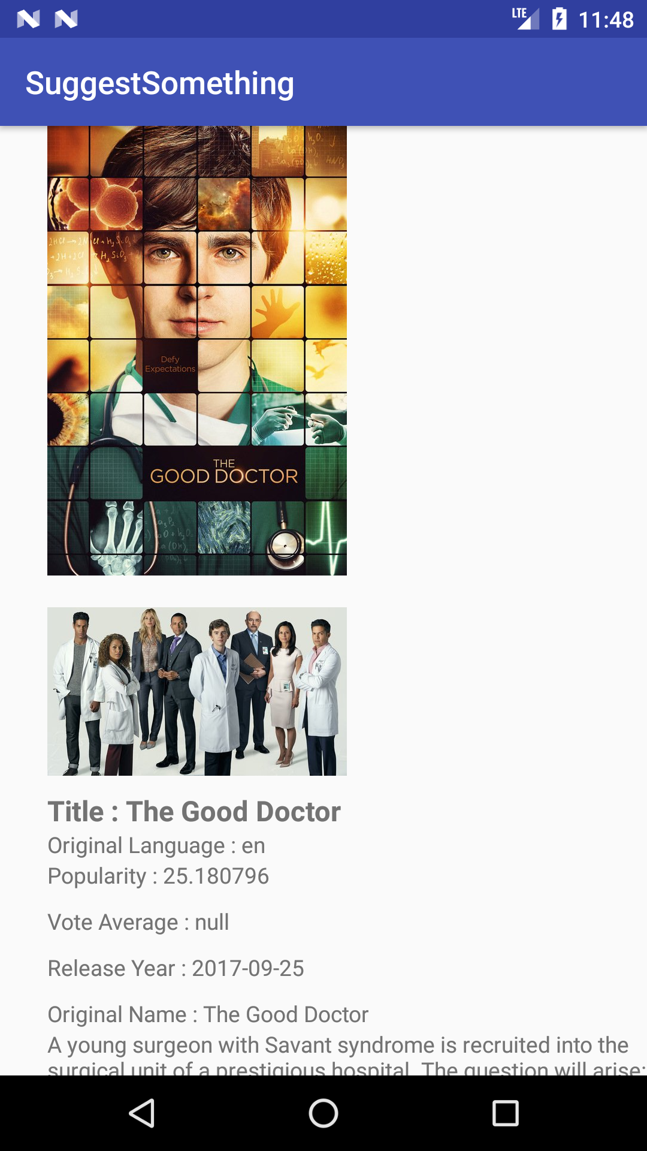 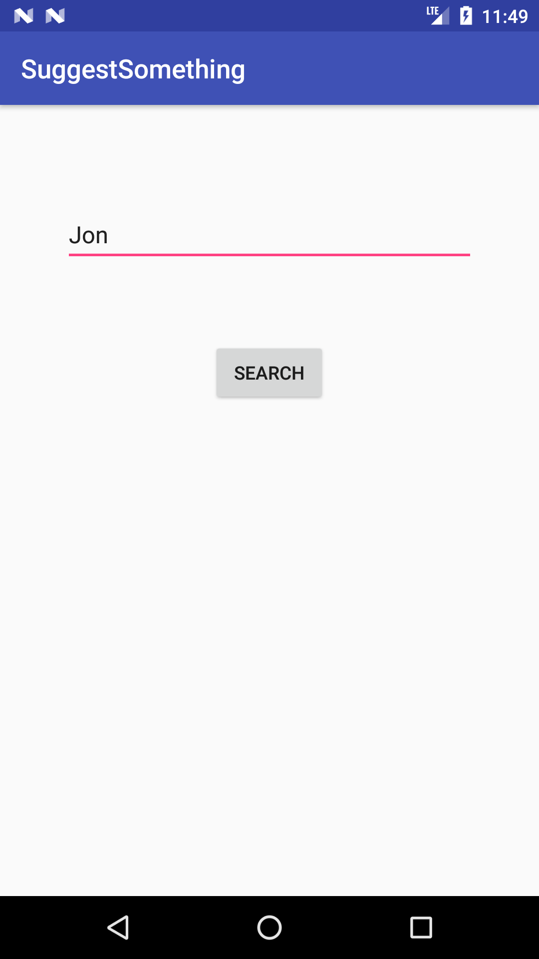

Search for an Actor Results Search for an Actor Results Details

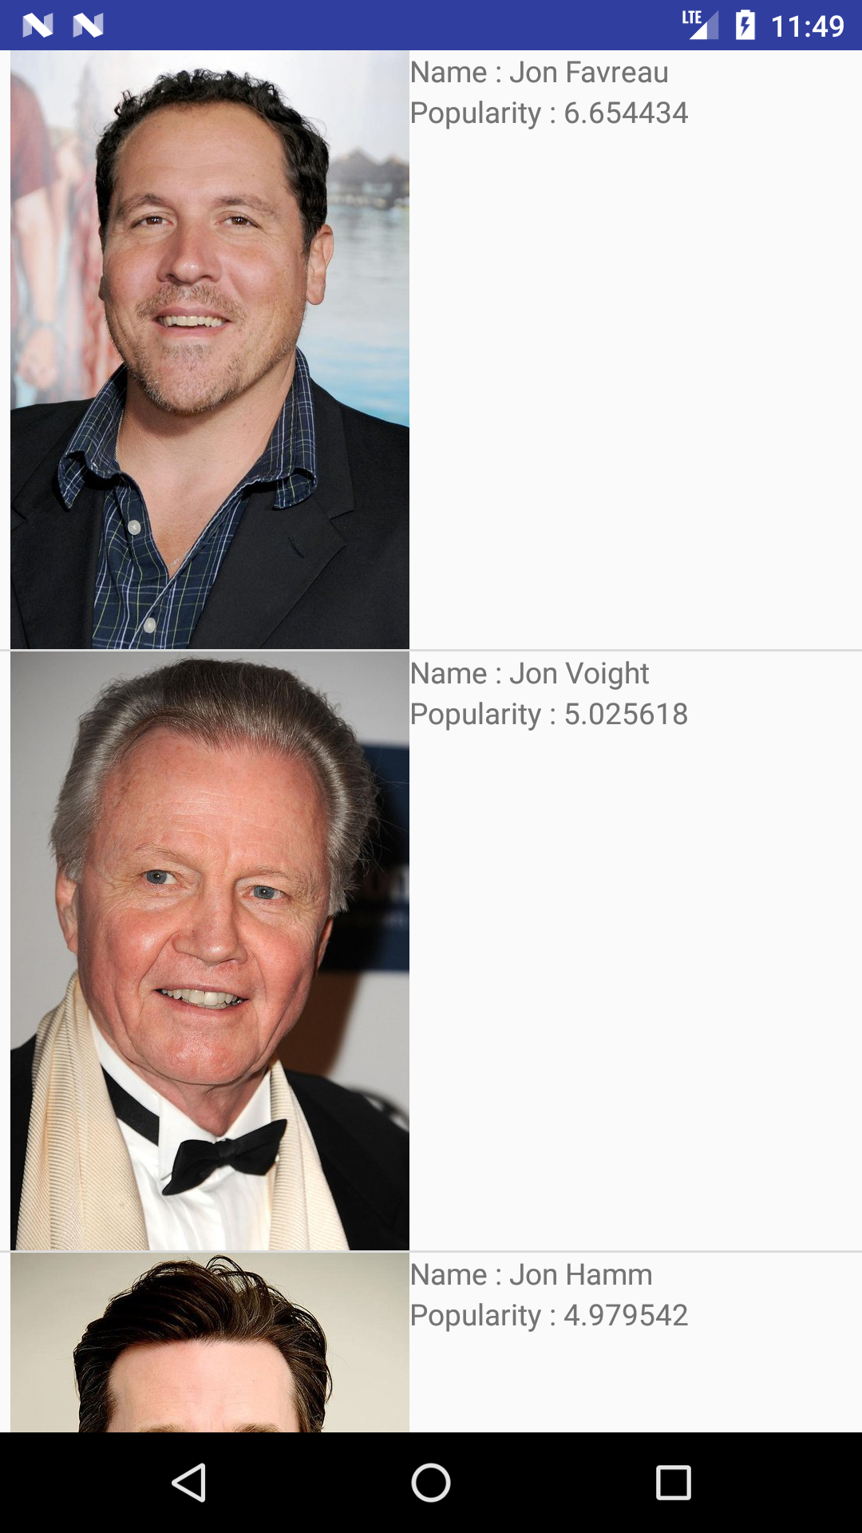 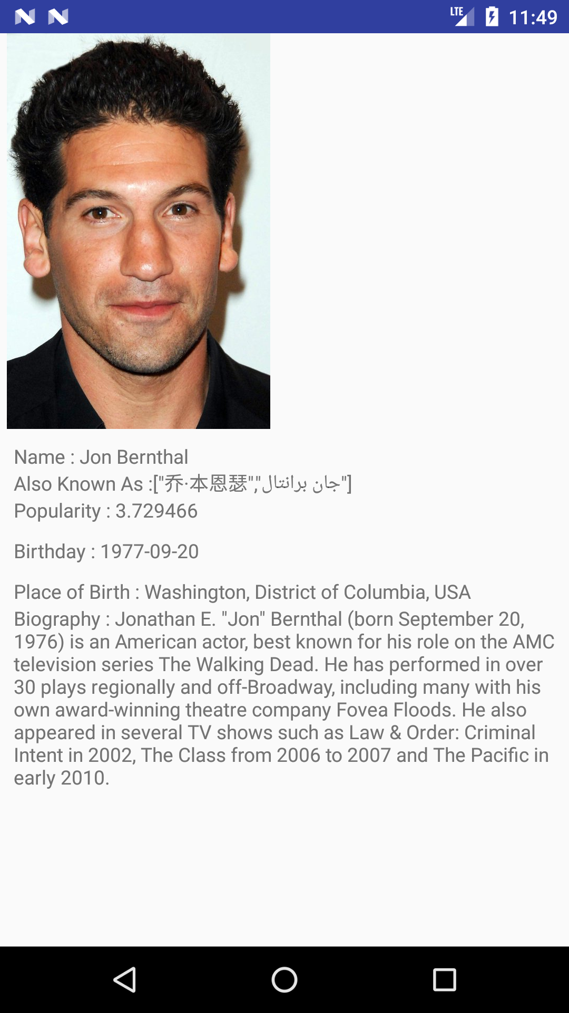

View Highest Rated- Movies Results View Highest Rated- Movies Results Details

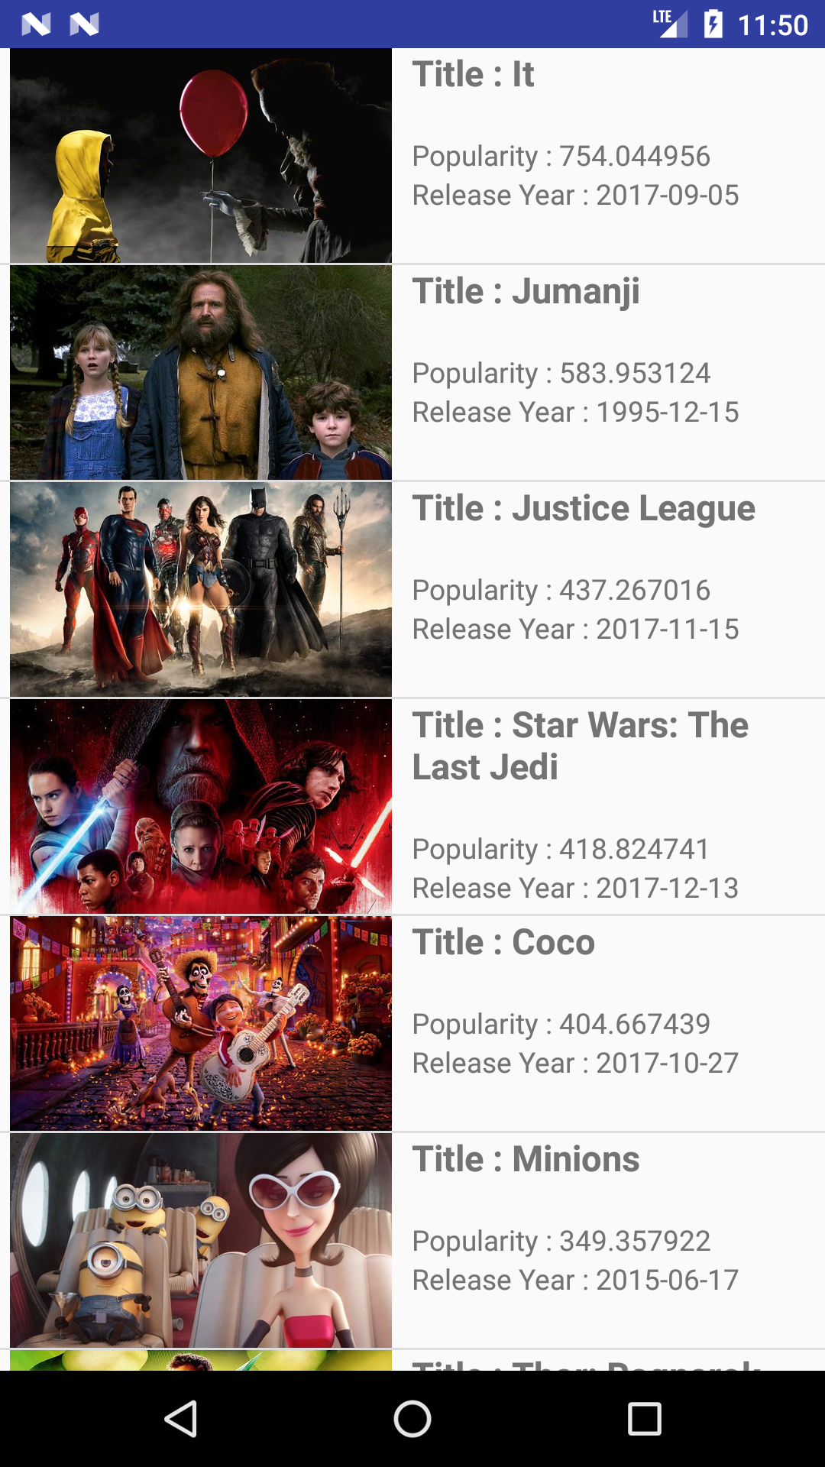 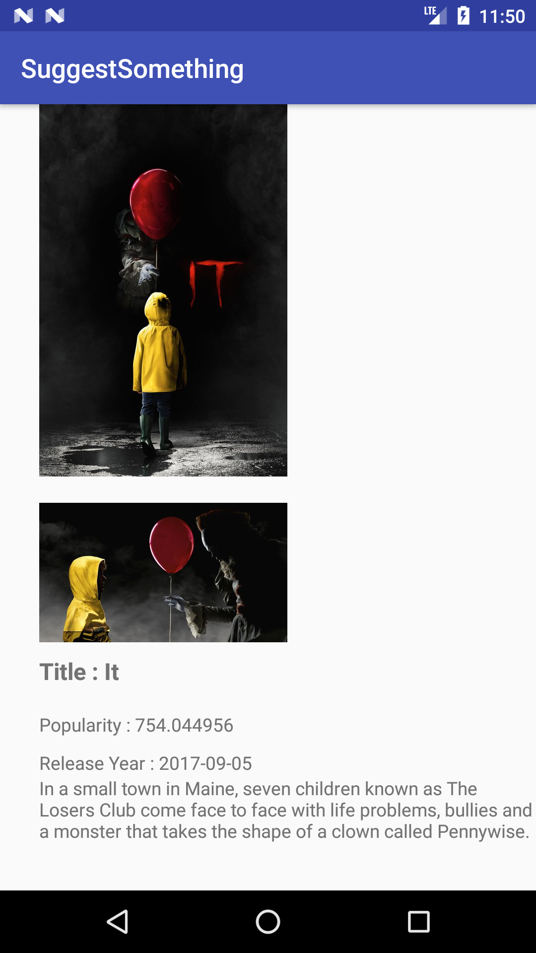

View Highest Rated – TV Shows Results View Highest Rated – TV Shows Results Details

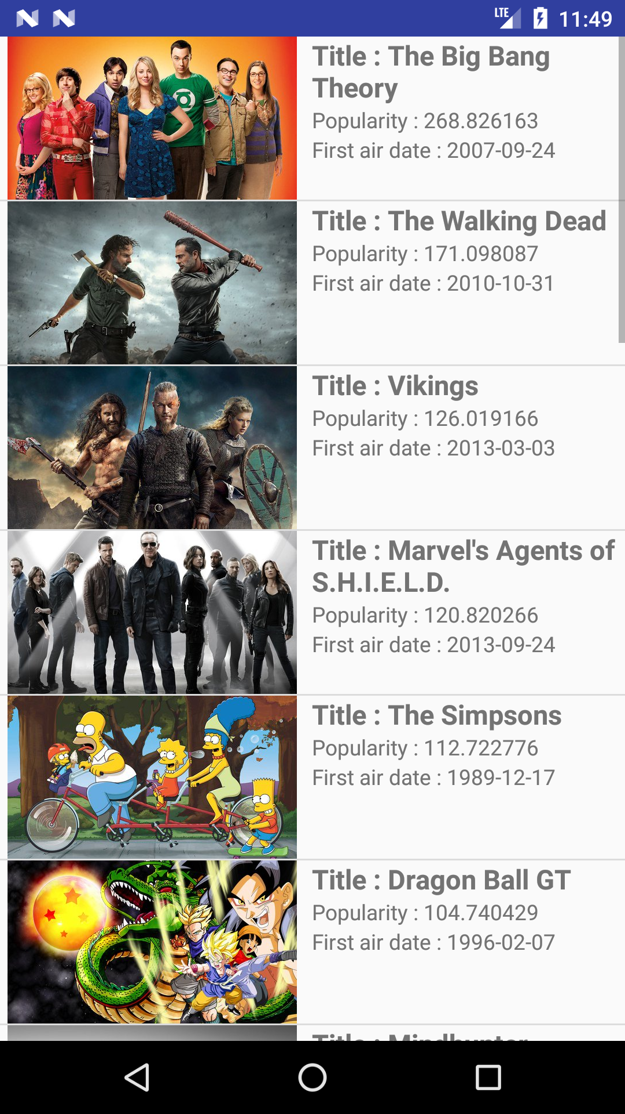 

**User Interface Content**

The user interface controls are as normal for most apps (utilize the back control for going backwards in the app, home and ‘all activities’ controls for viewing those things respectively). As for the controls in the views of the app, there are just a few buttons to “search” with, that can be pressed to be taken to the results of the query.

**Error Handling**

I handled any errors with error dialog messages appearing in a TextView on the screen. I also used Log statements to be able to see where a warning or error occurred.

**Essential (Core) Features I Had Proposed**

* Search media by title
* Search through media by rating (
* Search actors by name
* View specific details of media or actors from the list of search results

**Nice To Have Features I Had Proposed**

* User registration/logon system
* Ability to create watchlists (want to watch, have already watched, etc.)
* Ability to view trailers inside (or outside) the app

**What I Ended Up With in the End:**

* Search movie, tv show by title, view details
* Search actor by name, view details
* View most popular movies, and tv shows, view details

**Testing**

I conducted all of the testing myself. I tested the app with a lot of Log and print statements (most of which I erased before submitting the code) at every stage of development.

**Responsibilities**

Since I am my own team member, I believe I have made a good, equivalent contribution to this project, to the best of my ability.

**Notable Points:**

I chose not to organize the .java files into folder (such as all “Actor” .java files in one folder, “Movie” in another, etc.). The code for the search querying and parsing may seem a bit repetitive, this is because each __Results.java file has its own version of the TMDBQueryManager class, which all return a different type of ArrayList<typeResult> in the end. If I had more time, I might have added all of the connection/parsing result functions into one separate .java file, but that would consist of a lot of functions in which the only different things would be the return type, so I figured it was best to keep those functions in their own files. Thank you.

To build and run the project, you may need to follow whatever prompts display when trying to run it, and if nothing else works, then hit ‘Install APKs’ from the Build menu. If it still doesn’t work, then please let me know.